National Service Scheme
University of Calicut

REGULAR ACTIVITY REPORT

- Observed World Day against Child Labor, 12 June, 19
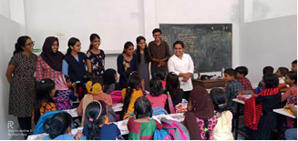 | 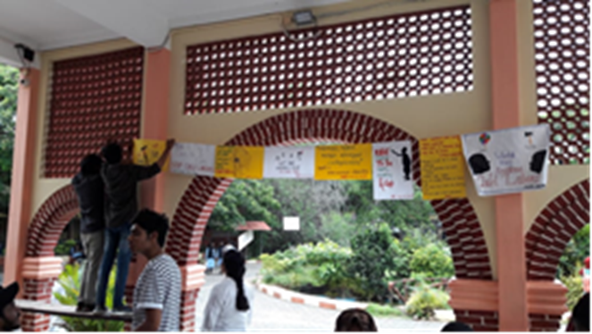
Organized programmes in nearby schools - Anappady and Pallaparam School and conducted Poster exhibition in the college denoting child labor issue
- Observed International Yoga day on 21 june . Observed International Yoga day associated with Dept. Physical Education On 21 June, 2019. 40 of volunteers participated in the yoga session . 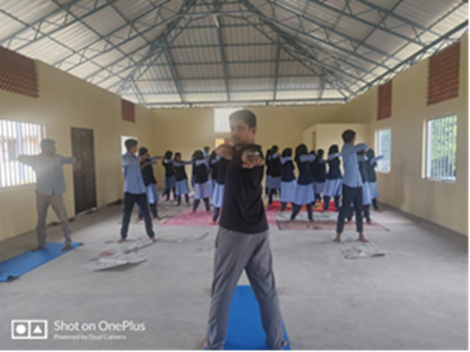

- Team building session: The units organized a team building session to the special camp going volunteers to strengthen their team spirit by organizing a session with Award won student volunteer Abhimanyu , Kalady Sreesankaracharya college handled the session on 18/06/2019 .
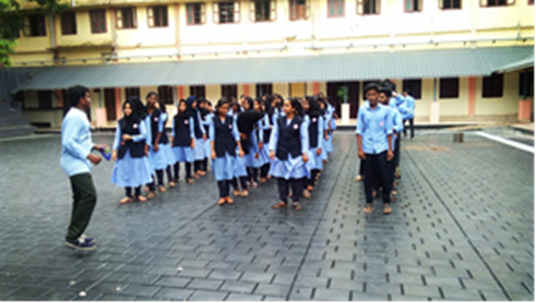
- World Youth Skill Day: Observed world youth skill day on 15 July, 2019 by exhibiting posters in the college and also arranged competitions regarding the youth skills .
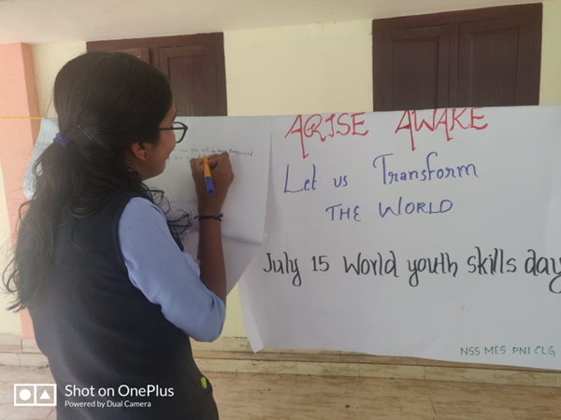
- Teachers day on 5 Sept. 2019 : the volunteers observed teachers day by gifting cards to teachers of the college
- Observed of Swachhta Pakhwada August, 2019: the units observed Swatchhta Pakhwada as directed by the government to drive out weeds and overgrown plants nearby roads of Ponnani under complete supervision of the complete government officials .
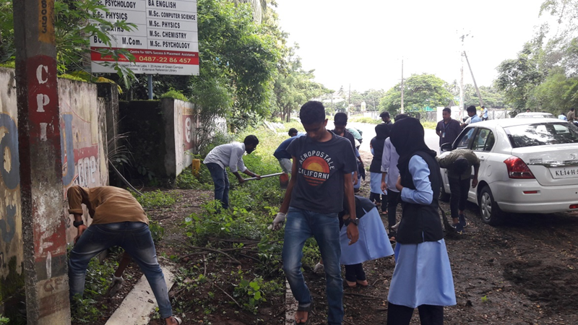

- Clean drive mission in and out of the college premises: The units carried out clean drive under the supervision of Ponnani Municipality.
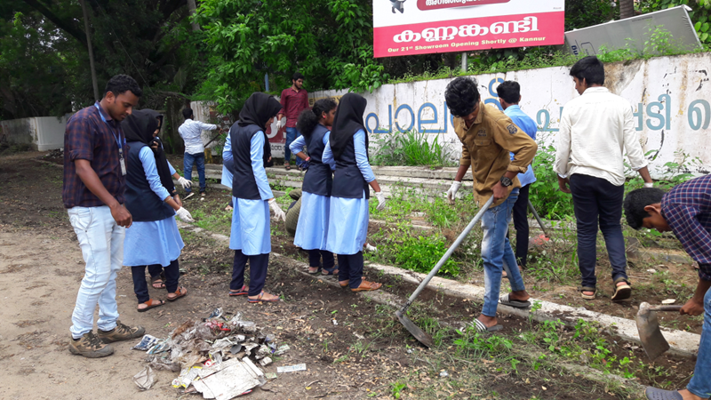

- Flood relief camp at MES Ponnani College – August 2019.
The volunteers actively participated in the flood relief camp at our college by giving their all man power to a smooth conduct of the camp. They also seek sponsors to get sufficient materials for the camp.
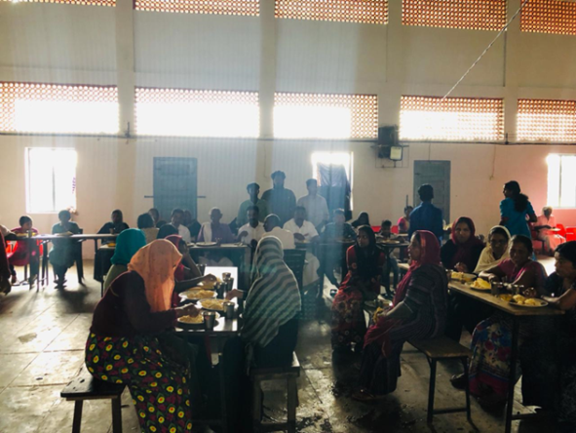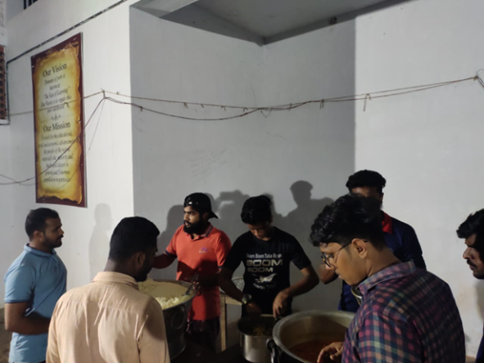

- NSS Volunteers Participated in Health and Well Being Mapping Programme – 7to 9 Sept. 2019. The volunteers turned out to be other event makers for Ponnani Municipality pioneer mission to get a survey on health and wellbeing of the inhabitants of the municipality to conduct it first ever in India. The also reported the issues of the people and handed over to municipality to create a logical survey.
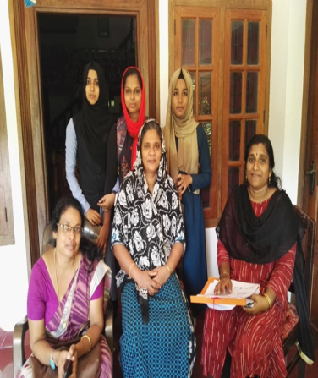 | 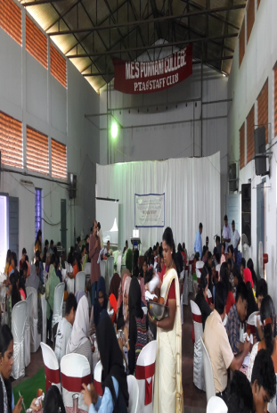 | 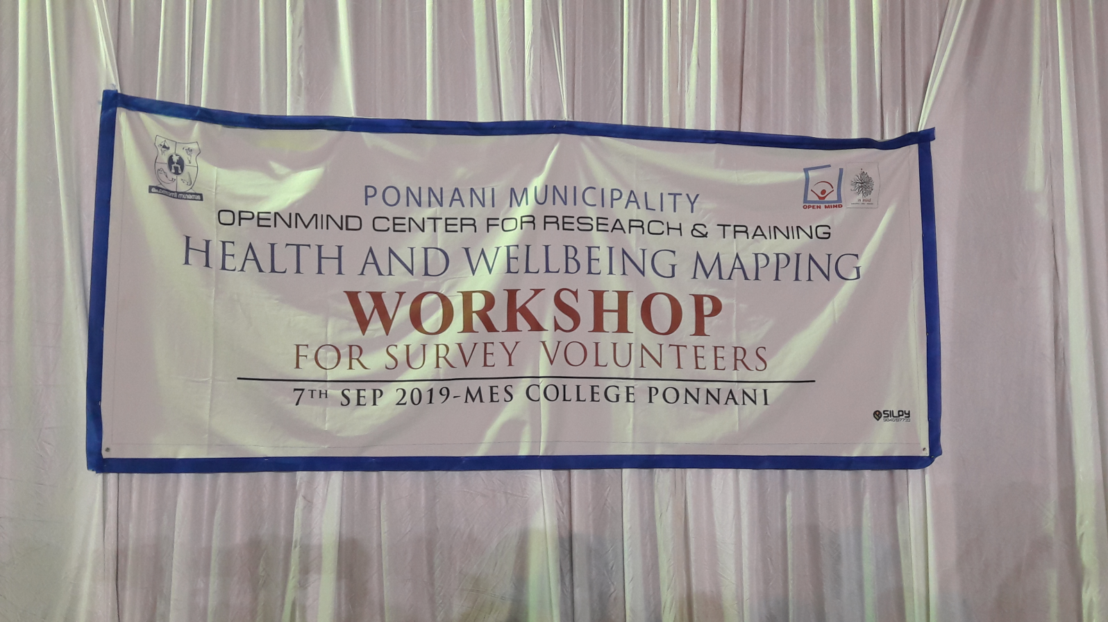

- Motivation Class for NSS Volunteers. The units conducted a motivation class to the first volunteers of the college. Motivation Class was class organised for NSS Volunteers on 24 october 2019. Ebrahimkutty master, Handled the session.
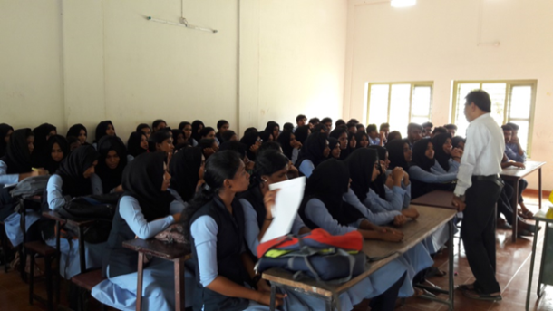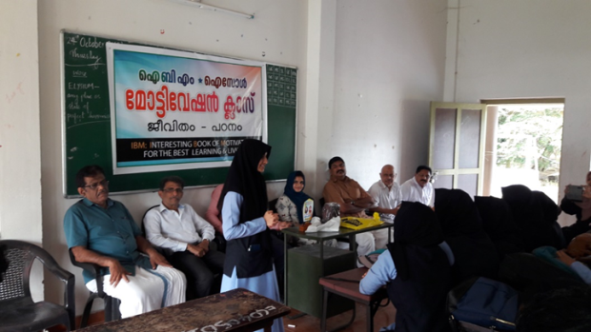

- Swach Nirmal Tat Abhiyan – (Dhesheeya Kadalora sucheekarana Yajnam) - MoEF&CC initiative: ‘Clean Our Blue Oceans and Beaches:- The units participated in the clean drive . NSS Volunteers actively participated in the cleaning drive organised by KSCSTE and KFRI at Padinjarakkara beach on 16 Nov 2019.
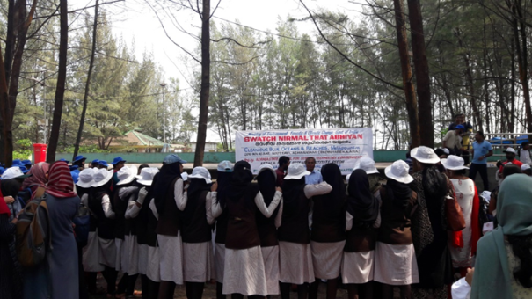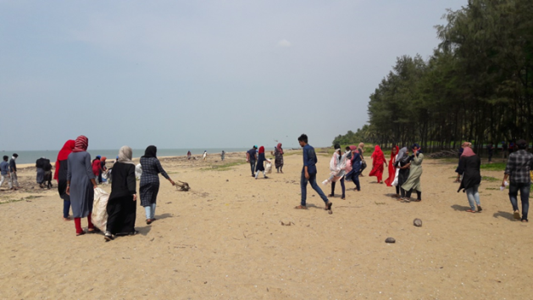

- Observed Children's day – 14 Nov 2019 by Visiting nearby LP schools – distributed sweets. And conducted a competition and distributed prizes for winners.

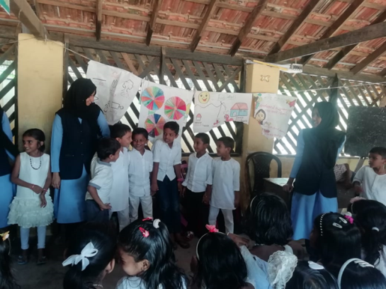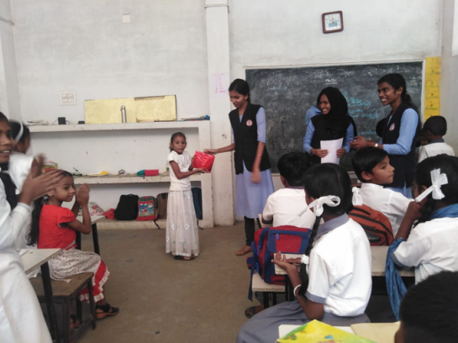
- Observed World Aids day -Dec -2019 .- The units observed world AIDS day and Conducted AIDS awareness rally and other Awareness programmes. The Taluk Hospital and Mother and child hospital, Ponnani took part in the observation. The doctors gave message. 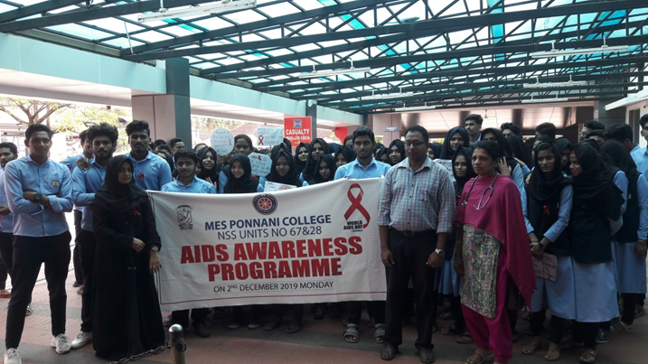

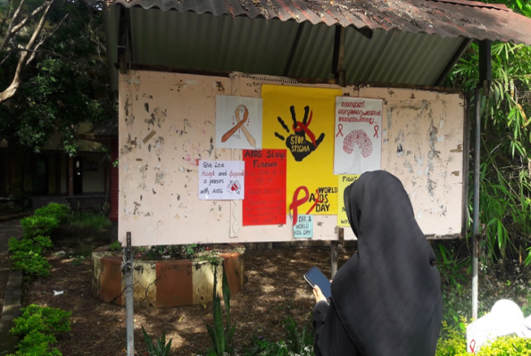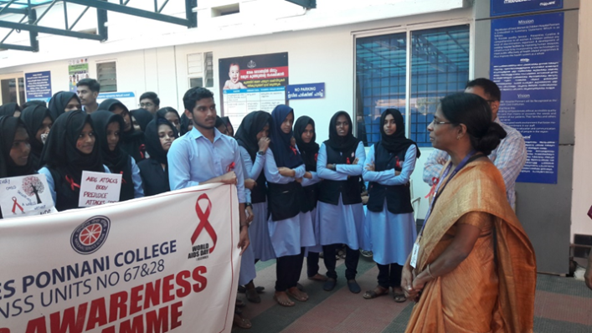
- Cleaned the hospitals: The volunteers took initiation to clean the hospitals of Ponnani at two different dates. Mother and Child Hospital on 3rd Dec-2019
Taluk Hospital -09 Dec 2019.
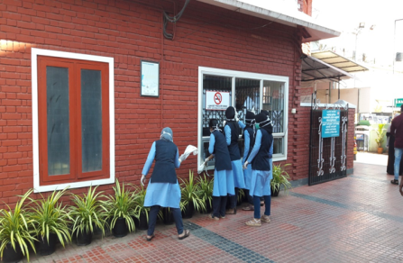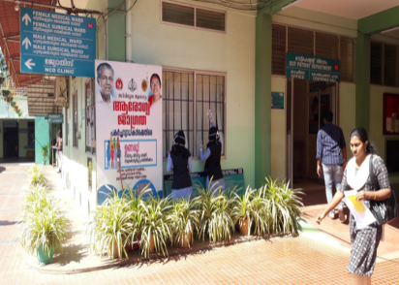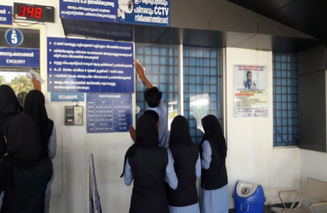

- Orientation Programme for 1st year volunteers : An orientation programme for the NSS first year volunteers organized on 14/12/19 . The class was handled by Sri. Salman, NSS Programme Officer, SAFA College, Valancheri .

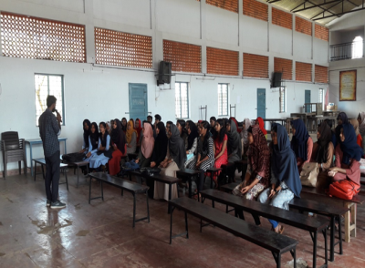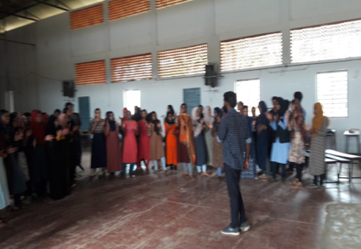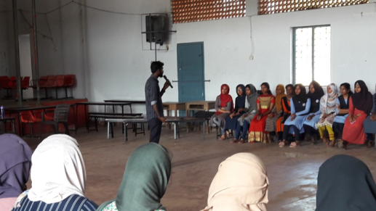

- Fund Collection for palliative care Units: The unit collected fund for child hood cancer care and distributed the amount to the Childhood cancer care unit, Kozhikode. The volunteers also involved in the Fund Collection Programme for Santhi Pain & Palliative care Unit – 15 Jan 2020.
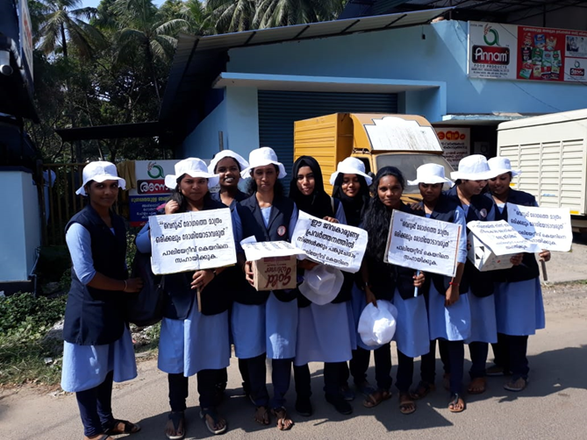
- Plastic waste management awareness: The unit conducted a plastic awareness campaign in association with Thanal, NGO, Thrissur. 20 of our volunteers participated in the event.
- Observed world cancer day on 4 Feb, 2020: The NSS units of the college observed world cancer day by arranging an interacting session with cancer survivors.
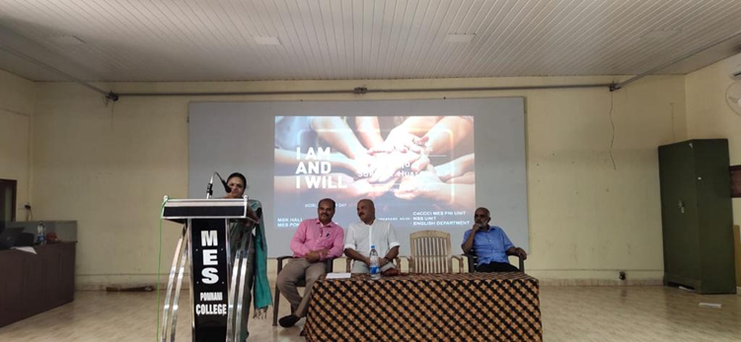

- Hand Sanitizer preparation – March 2020: With the Pandemic situation of Covid 19 virus, the units prepared hand sanitizer as it went scarce in the shops nearby. The units prepared it in collaboration with Chemistry department; NSS Volunteers prepared Hand sanitizers for Ponnani Municipality and various other organizations.
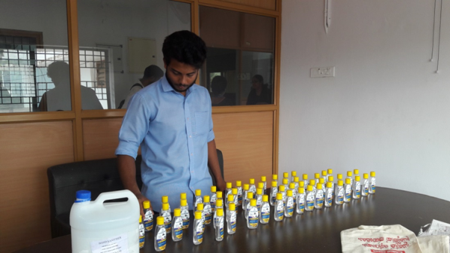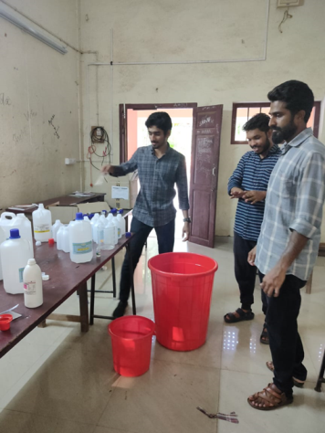

SPECIAL CAMPING PROGRAMME -2019-20

Detailed Day Wise Report on Special Camp 2019-20

The National Service Scheme special camp of the academic year 2019-20 commenced on 21 December 2019 at GLP SCHOOL Velliri .The camp was inaugurated by Ponnani Municipality President Mr. Muhammad Kunjhi in the presence of the college Principal Capt. Mohamed Koya and the counselors of the Municipality , Coastal Police, Port Engineers, Head Master, PTA members, and Managing Committee of the School. The project of the special camp has been named as "KADALOLAM", to understand and recognize the coastal plastic use especially that of the fishing boat into the sea .The main theme of the project is clean sea drive. To make the people aware of waste segregation and waste disposal particularly of Plastic. It is actually a curtain raiser of the mega project of Ponnani Municipality. Of the seven days in the camp the volunteers have been gained a lot of enlightening, influential and entertaining sessions. The classes were taken by skilled personalities on the topics like Leadership in action, group dynamics, Health and youth, Personality Development, Agriculture and Youth, Clean drive urges, plastic free awareness classes etc. Our proposed project was at the Ponnani harbor and Ward no 50 of Ponnani Municipality .We end up in recreating the school in much more Beauty than witnessed before and in the and installed a vegetable garden .The mission to give awareness to the fisherman community on the threat of plastic was successfully completed and the news being telecasted by the local news channel. The camp ended on 27 December, with a grand valedictory function. The valedictory ceremony presided by all the camp organizing committee.

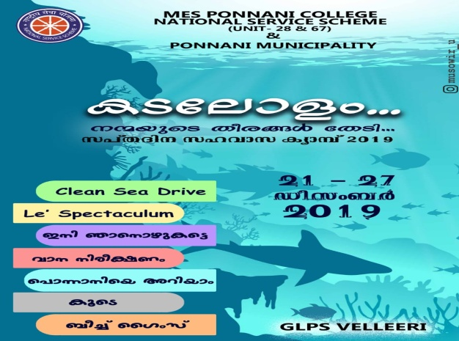 | 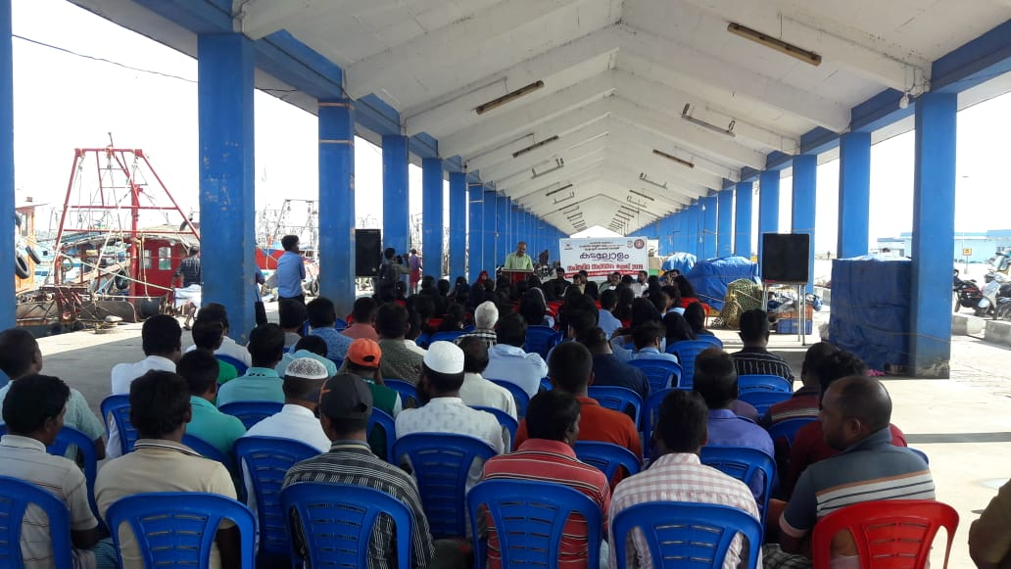

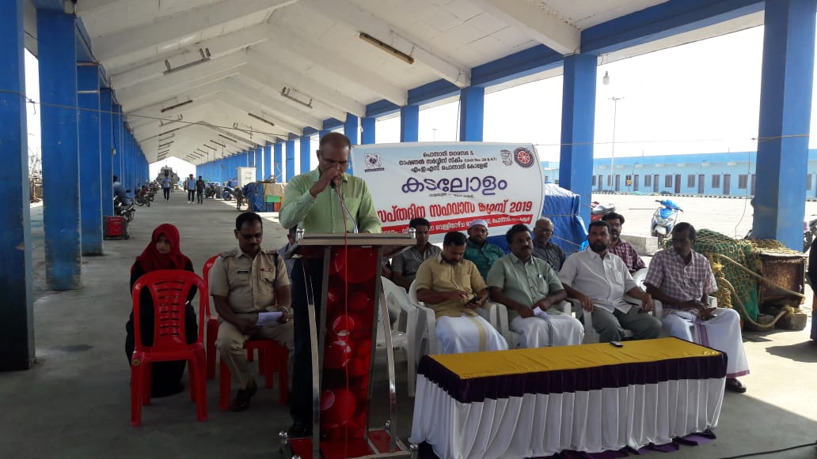 | 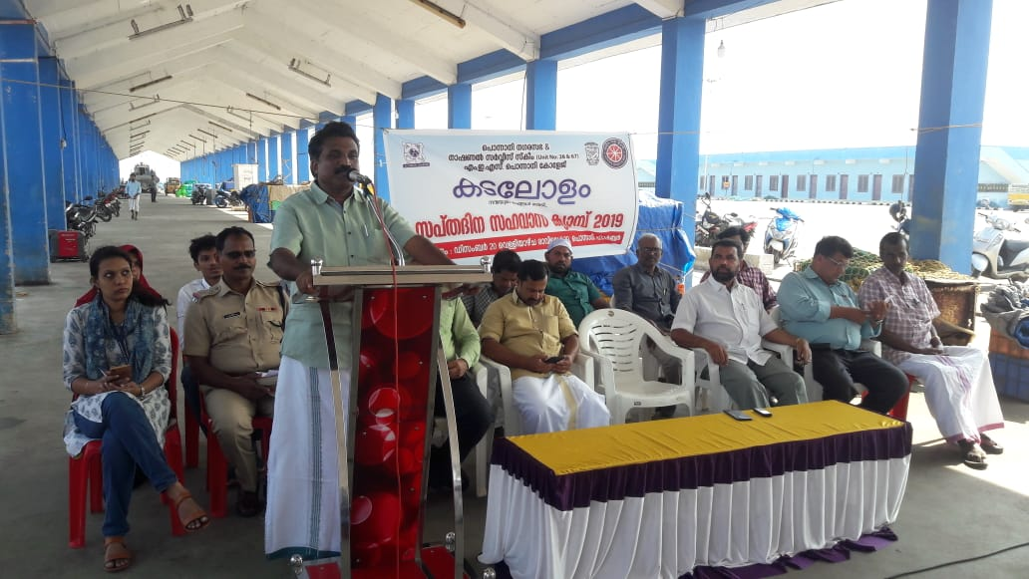

Day 1 (22-12-2019) Saturday
Inauguration ceremony started at 10.am, the camp was inaugurated by Ponnani Municipality President Mr. Mohammad kunji in the presence of the college Principal Capt. Mohamed Koya and the counselors of the Municipality , Coastal Police, Port Engineers, Head Master, PTA members, and Managing Committee of the School.. The first work the volunteers took in action was cleaning and ensuring the sanitary facilities and toilets in the school and the classrooms in the school. After the lunch break, an ice break session was handled by Farisha, V.M. to get know each other and to start the social living. In the evening, an informative cum entertaining session being handled by P Minshiya, Assistant Professor of Chemistry and former NSS Program officer MES College Walanchery on the topic “ Kaliyum Karyavum”.
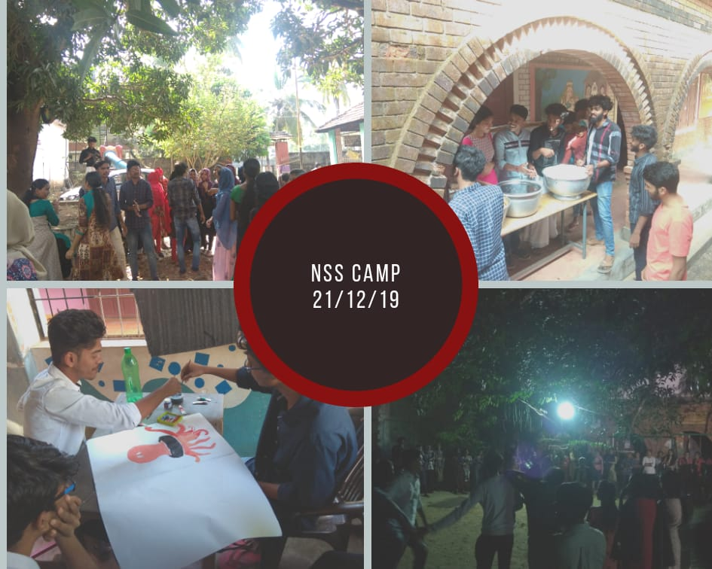 | 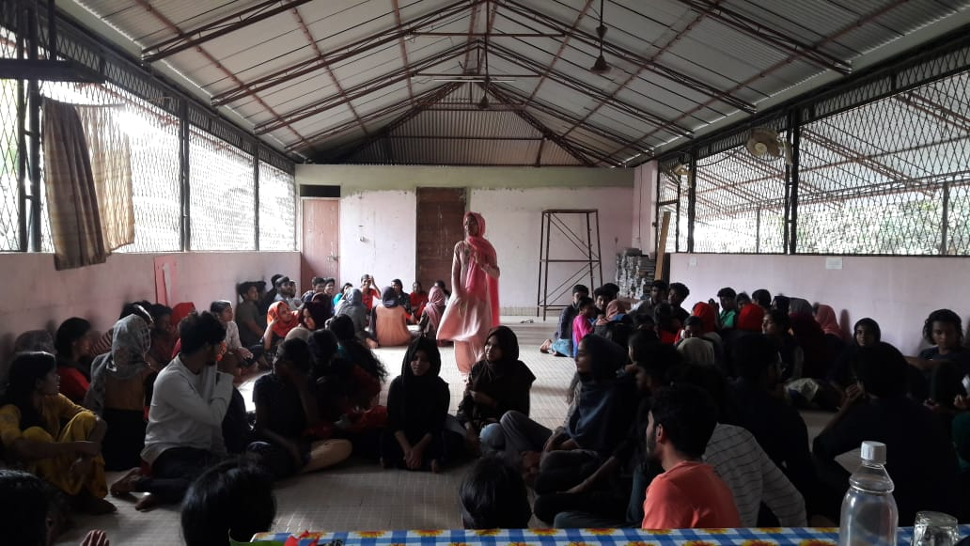

Day II (22-12-2018) Sunday

The Second day started with morning yoga practices to the students. The Morning assembly as per schedule started 6.00 AM, hoisted the NSS Flag, and released the camp news paper by the assigned group of volunteers .At 6.30 the volunteers started off to the harbor to recognize the plastic use of the fishing boat. To integrate the volunteers’ working together in team enhancement, a team building and leadership session was arranged and the session was handled by Sri. Rifa Shalees, Trainer, Olive Ridley. In the evening the camp was rejuvenated with programmes like debates and cultural programmes. The second day ended with camp review of the day.
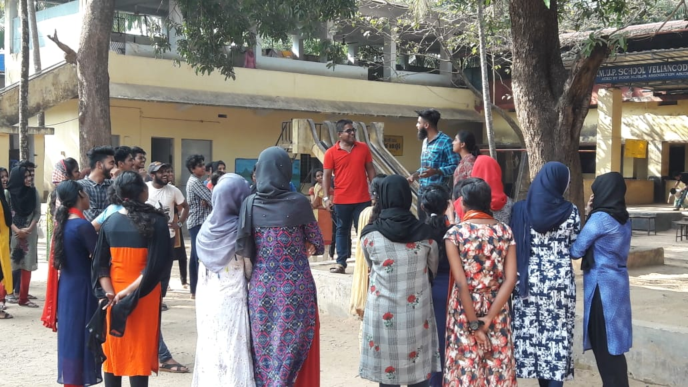 | 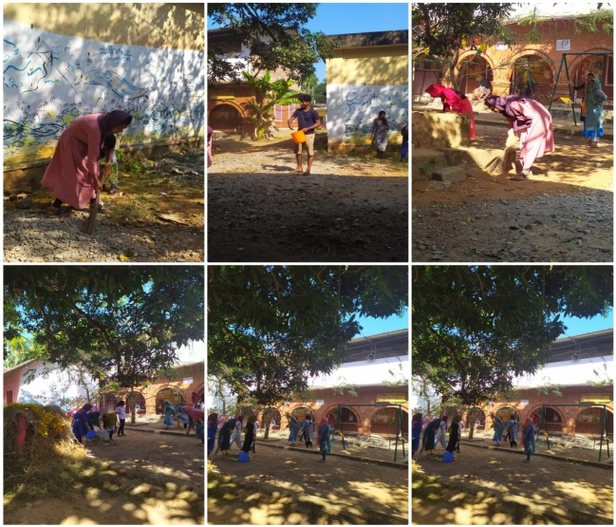

Day III (23-12-2018) Monday
The Third day started with morning yoga practices to the students. The Morning assembly as per schedule started 6.00 AM, hoisted the NSS Flag, and released the camp news paper by the assigned group of volunteers. The volunteers in the camp by dividing into group surveyed the Ponnani harbor and the workers of the fishing boat asking how healthy is their routine to deal with the plastic usage . It has been reported earlier by many NGO ' study report that people who go to the sea dumb plastic waste to the sea most. To build social commitment and awareness towards the nature and society, an en route session arranged , that was leaded by the wanderlust twin Ms Hafeeda and Hafeela to the outer nature to feel the rich heritage of the historical place. In the evening the camp was stimulated with various programmes like discussions and cultural programmes. The Th ird day ended with camp review of the day.
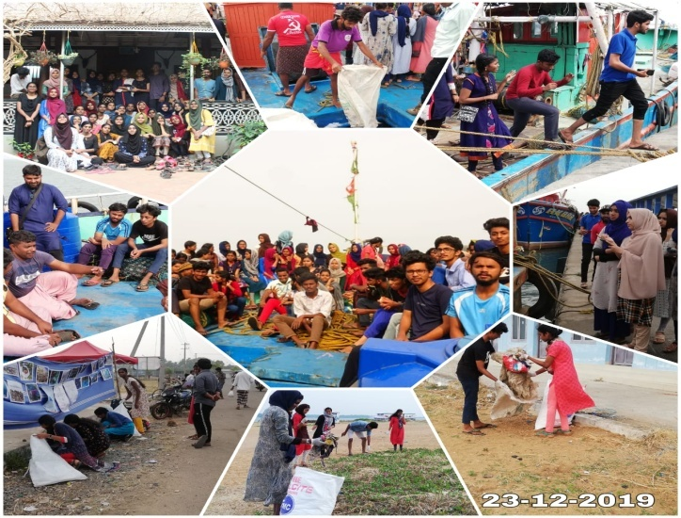

Day IV (24-12-2019 ) Tuesday
The Forth day started with morning yoga practices to the students. The Morning assembly as per schedule started 7.00 AM, hoisted the NSS Flag, and released the camp news paper by the assigned group of volunteers. The main activity of the day is a survey in the ward no 50 mainly the plastic waste and a survey given by university on electric usage in Google e forms. To build social commitment and awareness towards the community. The volunteer also distributed pamphlets announcing the threat of plastic and organized an exhibition in the Ponnani harbor noting all the threats to the fishes and the wealth of the sea because of the accumulation of plastic in the sea and selected volunteers gave awareness class to the public . In the afternoon session of day arranged a session by Riyas Pazhanji, Ward member Veliyancode Panchayath and associate Professor in Physics , he enunciated the role of Youth in Building Nation . As the routine call the camp rejuvenated with the cultural activities of the volunteers and after a satisfactory meal turned off the lights and bid goodnight .
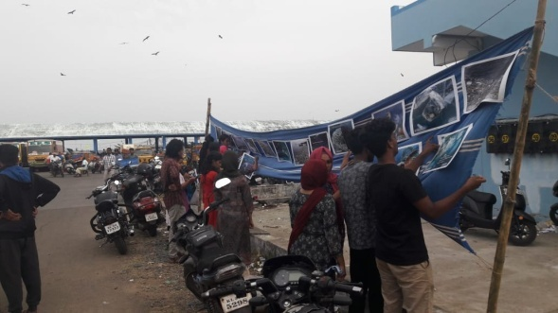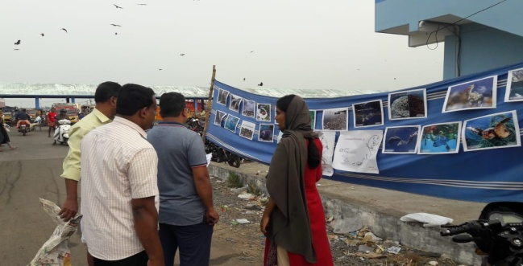

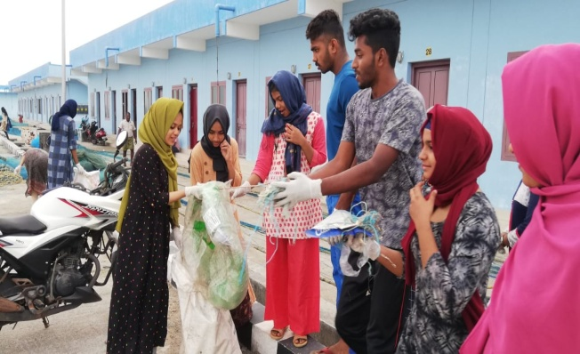

Day V(25-12-2018) Wednesday
The Forth day started with morning yoga practices to the students. The Morning assembly as per schedule started 7.00 AM, hoisted the NSS Flag, and released the camp news paper by the assigned group of volunteers. The main activity of the day is a survey in the ward no 50 mainly the plastic waste and a survey given by university on electric usage in Google e forms. To build social commitment and awareness towards the community and in the camp invited children with special abilities and celebrated X'mas day with them. informative session arranged, that was guided by Dr. V.K. Brijesh. Assistant professor, of geology on the topic “Man and environment”. In the evening the camp was stimulated with various programmes like discussions and cultural programmes. The Forth day ended with camp review of the day.
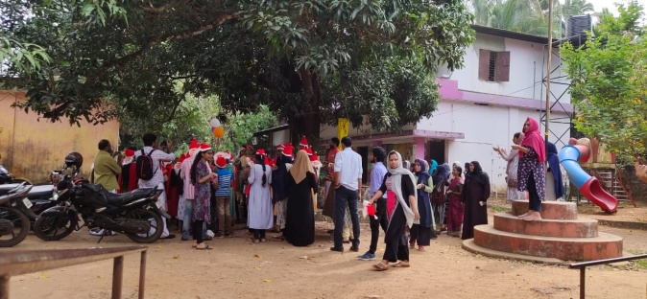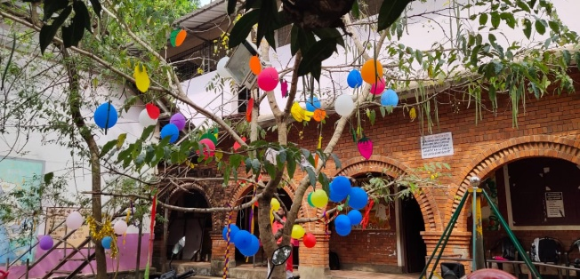
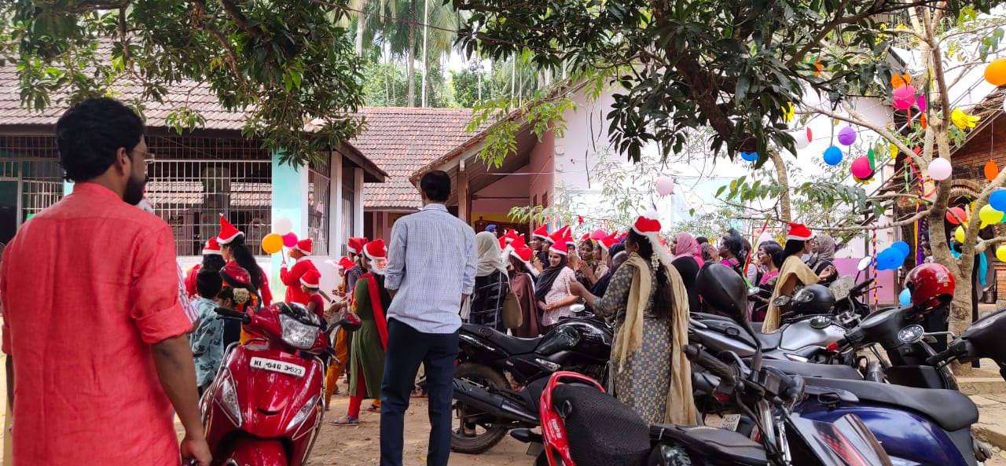
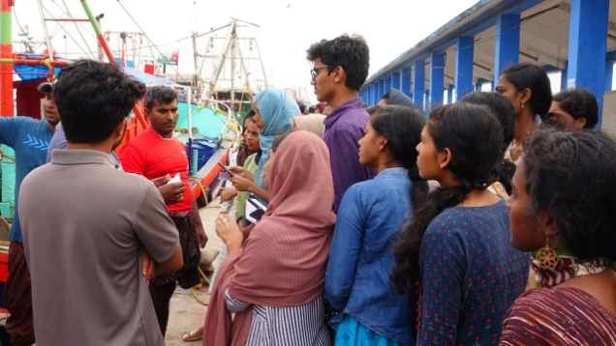

Day VII (26-12-2018) THURSDAY
The day started with walkathon to Ponnani Harbor to feel the fragrance of Morning breeze of the cold morning to the students. The Morning assembly as per schedule started 7.00 AM, hoisted the NSS Flag, and released the camp news paper by the assigned group of volunteers. On this day volunteers go out to clean the rivulet proposed by Ponnani Municipality . Very zealously volunteers participated in the clean drive . In the afternoon session on Plasitc: Truth & Solution, handled by Ms Sangeetha Pradeep (Assi Director, Pesticide Action Network India) “In the evening the camp was filled with various programmes like discussions and cultural programmes. The Fifth day ended with camp review of the day.
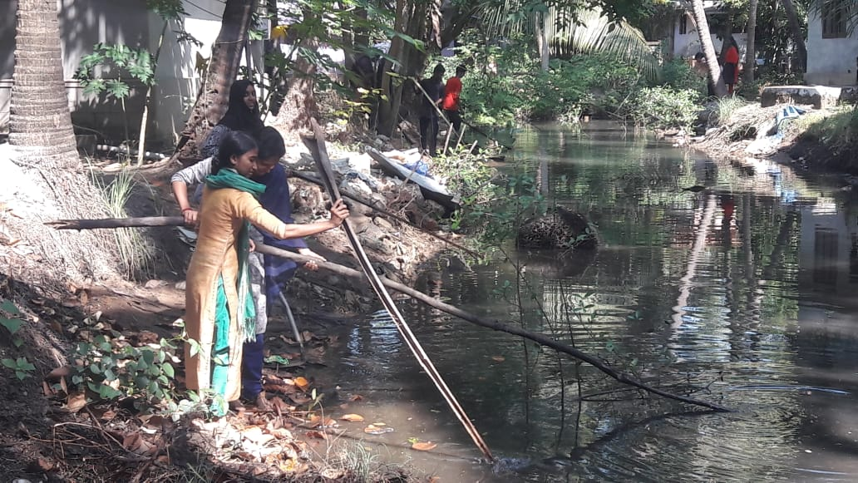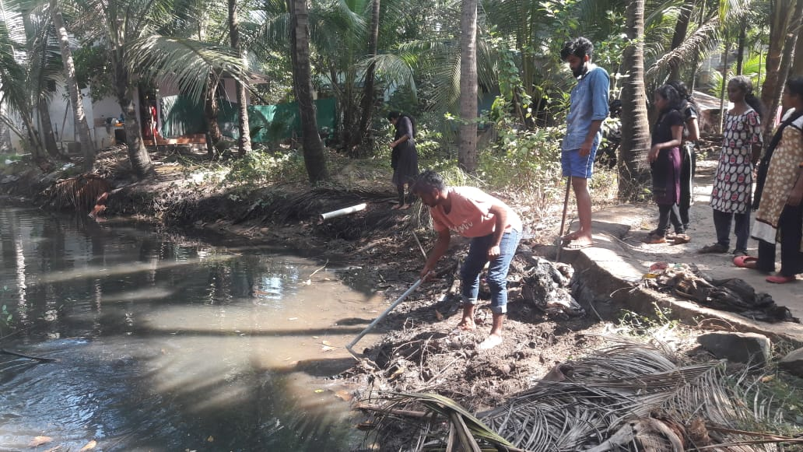
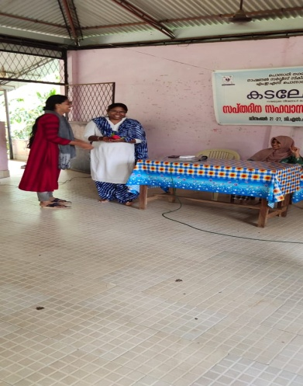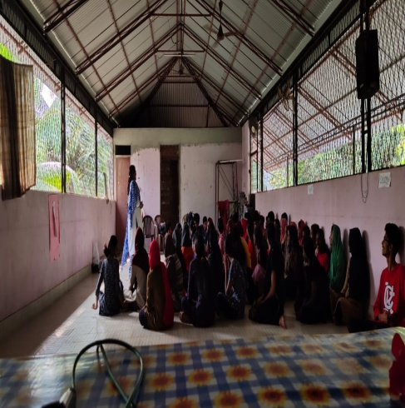

Day VII (27-12-2018) FRIDAY

The day started with morning yoga practices to the students. The Morning assembly as per schedule started 7.00 AM, hoisted the NSS Flag, and released the camp news paper by the assigned group of volunteers. On the concluding day of the special camp volunteers cleaned the school surroundings, the class rooms and, and they packed their luggage to leave from the camp. In the feedback session they shared their experiences and articulated their view on being in the camp. valedictory ceremony presided by the Abdul Nafih, Programme Officer National service Scheme and the president of Ponnani Municipality inaugurated the function and the counselors and officials of the Ponnani Municipality came to the valedictory function to bid us off.
